Parts of nodes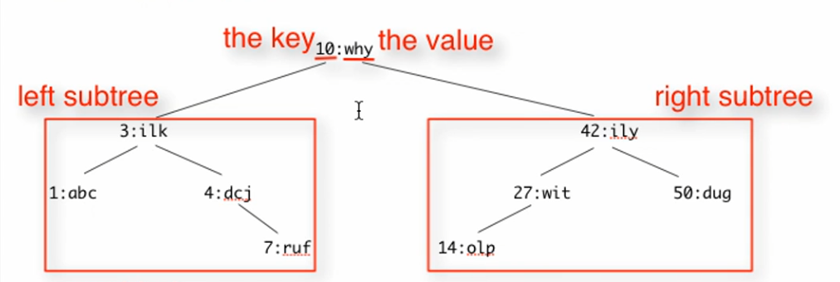

* 4 parts that naturally go together: use COMPOUND DATA
* Left subtree & right subtree are arbitrary sized!
  + 2 self-reference cycles – one for the left and one for the right

Data definition

Structure



Type comment



Base case:

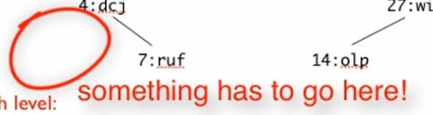

* + Like empty in list

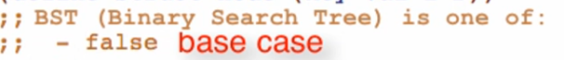

SR Case:

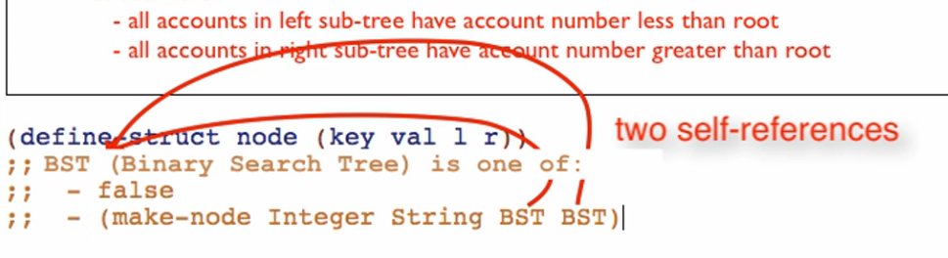

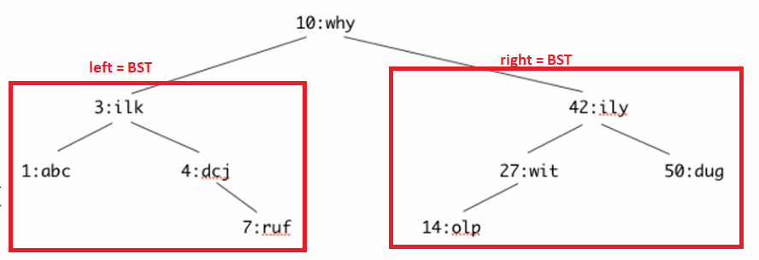

Interpretation

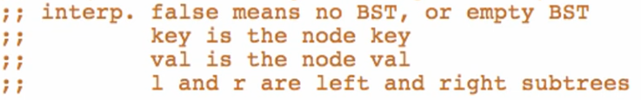

Also include the note of the BST of its “INVARIANT” (true for the whole tree)

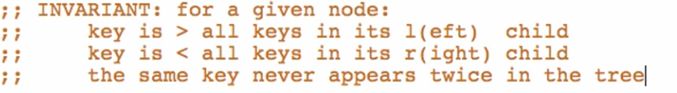

Examples

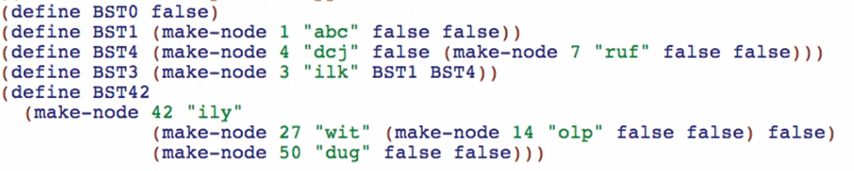

Run to see if well-formed

**Template**

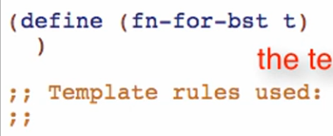

* One of: 2 cases:

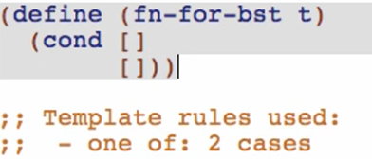

1st case: atomic distinct false

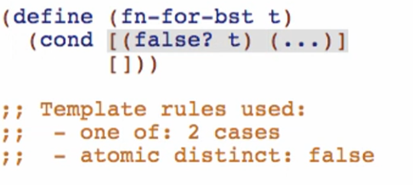

2nd case: compound: 4 fields (make-node Integer String BST BST)

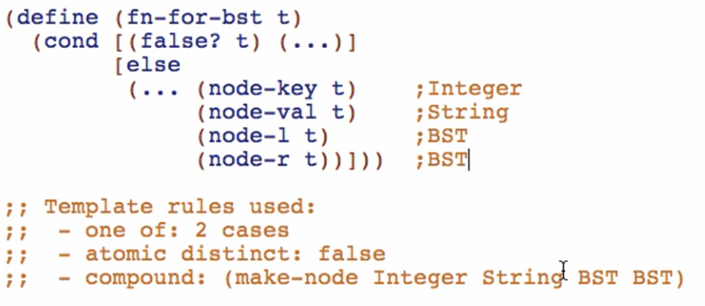

* Self-reference case: (node-l t) has type BST

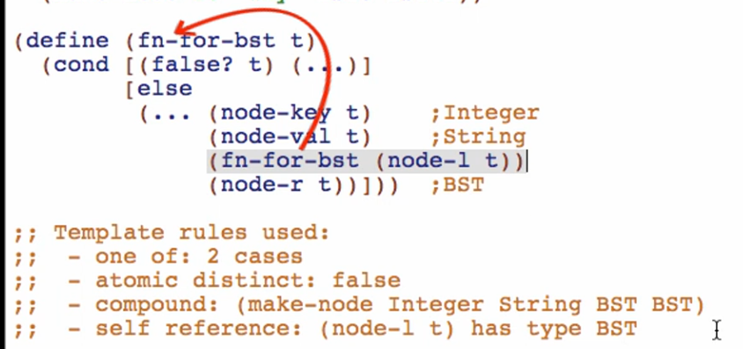

* Self reference case: (node-r t) has type BST

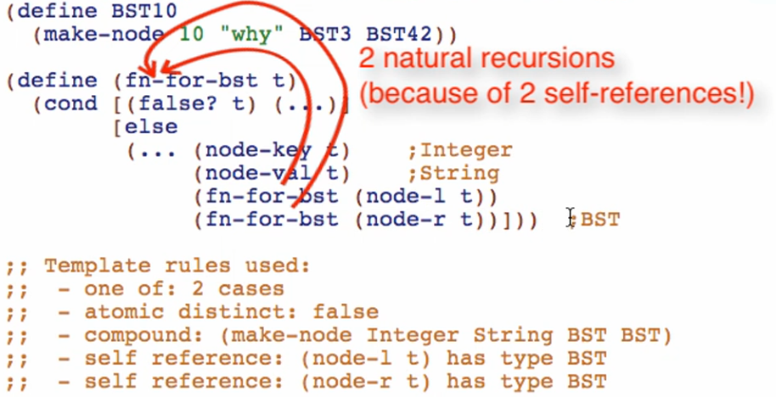

Run to check if well-formed!